Before we go into torque, here’s a little exercise to try out (yes, it involves doors). With a friend and a door, have your friend push the door open normally, by the doorknob. While they are pushing the door open, try and push back door close to the hinge (be careful not to apply too much force and slam the door into each other). Notice how much force you need to apply to resist the door opening. Now switch positions; notice how much force you need to apply to open the door.

This raises an interesting question; why does the person pushing near the hinge need a lot more force to overcome the force being applied near the doorknob? To understand what’s happening here, we need to add another tool to our physics toolbox: torque.

Torque is the turning effect of a force. If a force would cause an object to rotate, like pushing on a door, that force is applying a torque. Mathematically, we represent torque as

$$τ=rF_{⊥}$$

The r is the distance from the axis of rotation in which the force is being applied, and the F is the force perpendicular to the r. Notice that torque is a vector, and therefore has a direction. However, for torque, we don’t apply the traditional up, down, left, right, and so on. Instead, we consider torque to be acting in two directions, clockwise and counterclockwise. A net torque of zero means that all the torque going counterclockwise is equal to the force going clockwise. The units of torque or Nm.

Let’s go back to our door example, and try to figure out why the person pushing the door by the doorknob will generally beat out the person pushing near the hinge. If both pushers are pushing at relatively the same amount of force, we can say the force part of the torque is the same for both pushers. However, torque is both dependent on force and the distance from the axis of rotation, in this case the hinge. The person pushing closer to the hinge has a smaller r than that of the person pushing by the doorknob. Notice that in the equation for torque, if r increases, torque increases as well. Thus, we can see why the doorknob pusher has the advantage; their r is larger, so their torque will generally be larger as well.

The r in our equation above references an axis of rotation; what if the object is not rotating at all? This situation gives a freedom when working with problems. If the net torque is zero, then we can put the axis of rotation wherever we want along the axis of (something something). For example, in the case with the door, if it’s not rotating, then we can put the axis of rotation anywhere along the axis of the door; we could put it on the doorknob, the hinge, the middle of the door, or even miles away from the door, as long as the door is not rotating. A general rule of thumb is to put the axis of rotation on a point where a force is acting that we do not know and we’re not looking for.

(example 1 start)  
  
The pedals of a bicycle rotate in a circle with a diameter of 40cm. What is the maximum force a 55-kg rider can apply by putting all her weight on one pedal?

Let’s start by considering the situation. The rider applies their force at the end of the pedal, and the pedal rotates at the center, so the distance away from the axis of rotation the force is being applied to should be the distance of the pedal from the center, or the radius of the circle the pedal makes. The diameter is 40 cm, so the radius is 20 cm, or 0.2 m. Next, if the maximum force the rider can apply is all their weight, then the maximum force is equal to the force of weight on the rider, mg. The mass of the rider is 55 kg, so the force is (55 kg)(9.81 kg/N), or 539.55 N. Now we can take our definition of torque and solve for these values, so: $$τ=\left(0.2 m\right)(539.55 N)$$

Evaluating this gives us 107.91 Nm, which is the maximum torque.

(end example 1)

(example 2)

A bolt is screwed into a machine you are trying to disassemble, and it needs a torque of 20 Nm to unscrew. How much force do you need to apply to the end of a 30 cm wrench, at an angle of 30 degrees from the wrench, to unscrew the bolt?

A good starting place with any problem is a simple drawing of the problem:

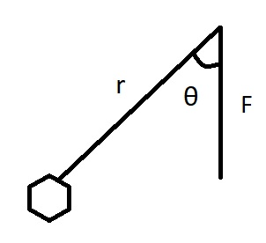

Here, r is the length of the wrench, F is the force applied, and θ is the angle the force makes with the wrench. Going back to our definition of torque,

$$τ=rF_{⊥}$$

we have the torque, which is the minimum torque needed to unscrew the bolt, and we have the distance from the axis of rotation to the force, which is the length of the screw. Since the force we’re looking for is the force perpendicular to the lever arm, in this case the wrench, and so we need to find the perpendicular part of the force:

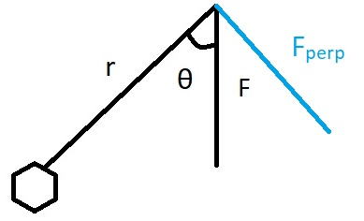

Since the perpendicular part of the force is perpendicular to the wrench, we know the angle it makes is 90 degrees, and so we know that the angle between the force and its perpendicular part is (90-30) degrees, or 60 degrees. F⊥ is the adjacent to the force, which tells us that F⊥=Fcos(60). Now we have all the parts to solve for F. Substituting our values into the definition of torque:

$$20Nm=(.3 m)(Fcos(60))$$

Solving for F brings us to:

$$F=\frac{20Nm}{.3m (\cos\left(60\right))}$$

Which gives us a force of 133.33 N, which is the force needed to unscrew the bolt.

(end example 2)